Fig. S2 CIRCOS visualization of geneomic and transcriptomic features
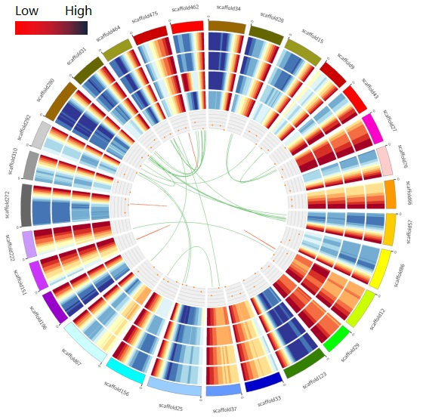

The meaning of circles represent as follow (from outside to inside):
- Flax scaffolds
2. Density heat maps of genes on the genome
- Density heat map of the transcript on the genome
- Density heat maps of genes on PacBio
- Density heat map of the transcript on PacBio
- Density heat map of LncRNA on PacBio
- Connection diagram of fusion transcript. PS:Fusion between scaffolds showed in green. Fusion internal scaffold showed in red.

